Lecture 27

CPSC 131  
12/9/2020

1. Depth-First Traversal
   1. DFS Traversal Terminologies and Sketches  
      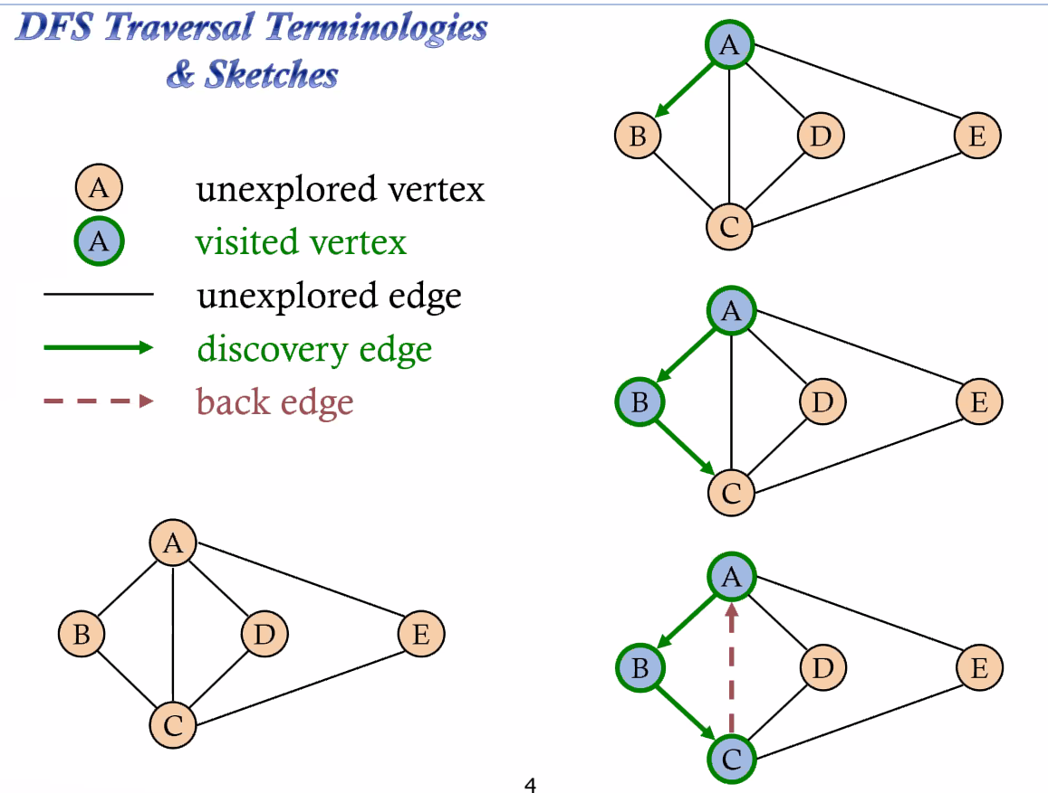
   2. Note that it’s structured like a stack. When we process go move one element from the stack to the top.   
      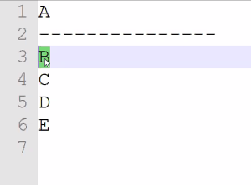 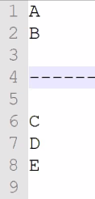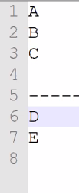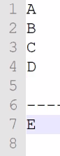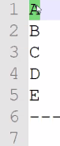
   3. Now the Depth-First search traversal in action  
      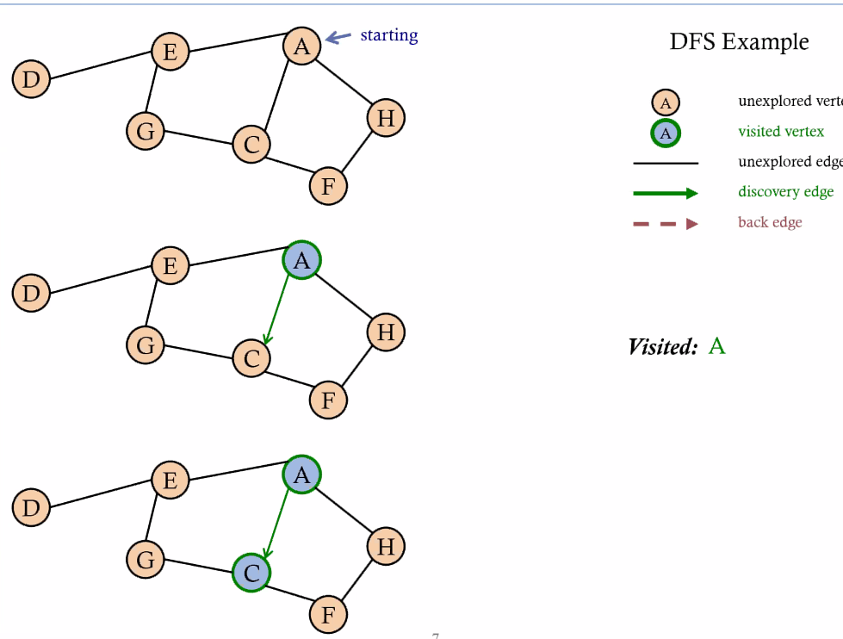  
       A talks to E C F H which leads to   
      And it visits F then H  
      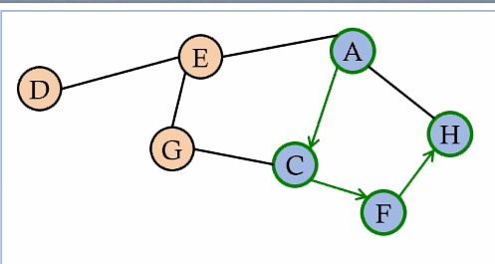   
      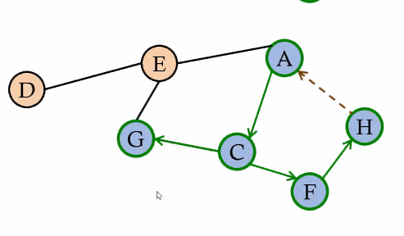Then G   
      Finally the final element  
      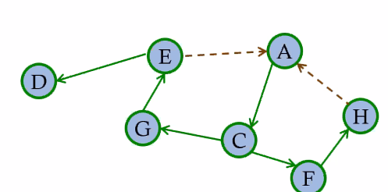
   4. Analysis of DFS  
      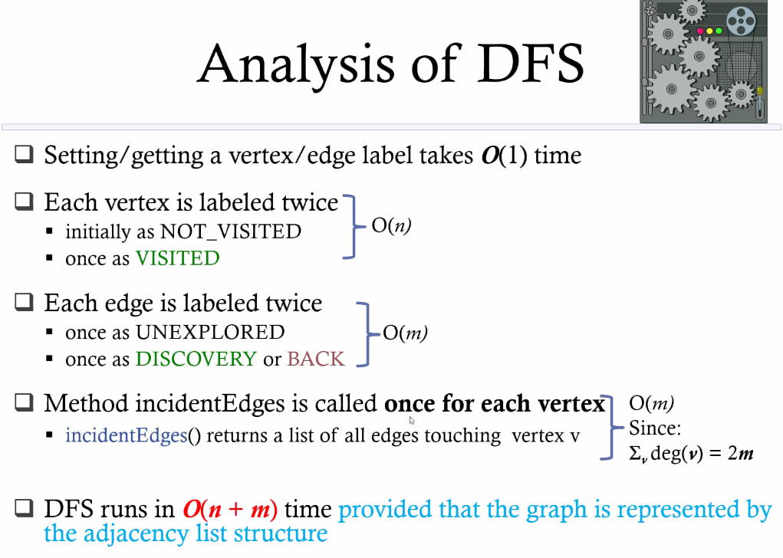
   5. DFS Algorithm Pseudo Code  
      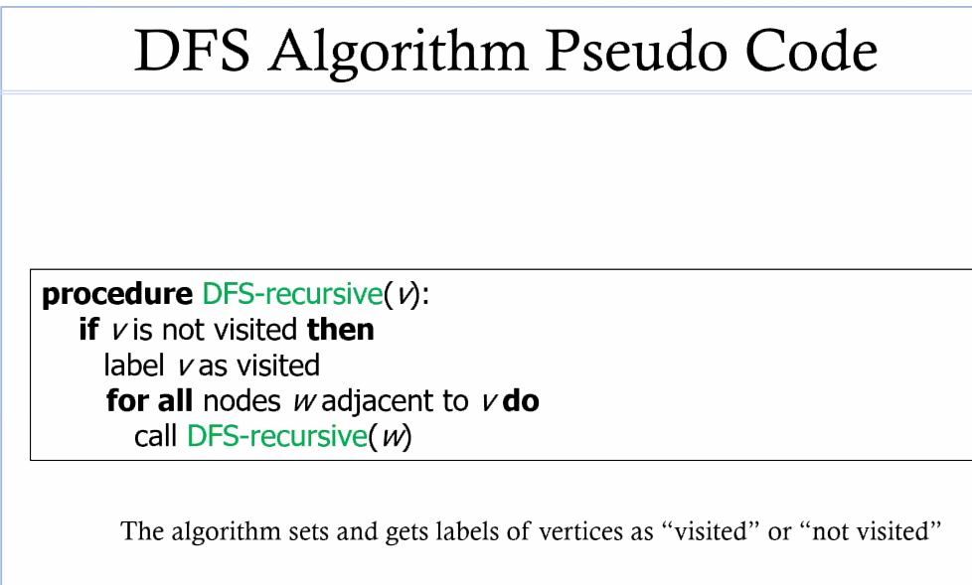
2. Breadth-First Search (BFS)
   1. In this search, we(L0) talk to three friends(L1) before we let them talk to their friends (L2).   
      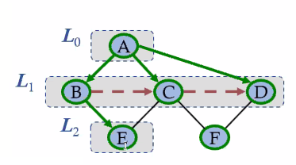
   2. BFS Algorithm Pseudo Code  
      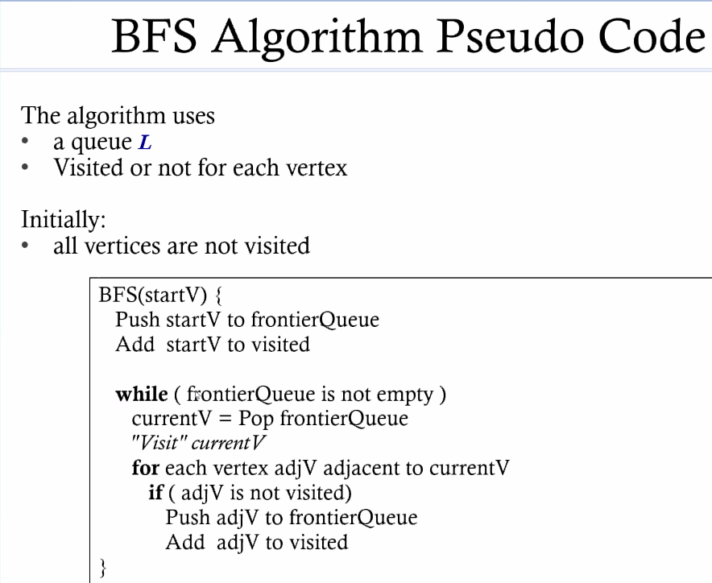
   3. Analysis of BFS
   4. Traversal and Sketches  
      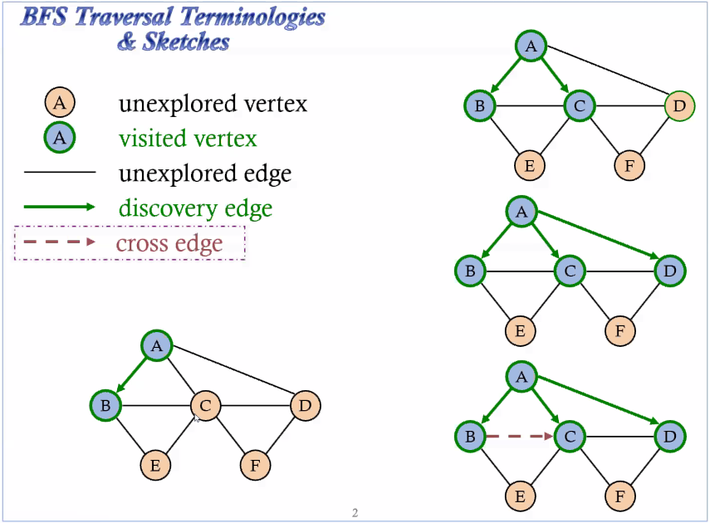
3. Final Project  
   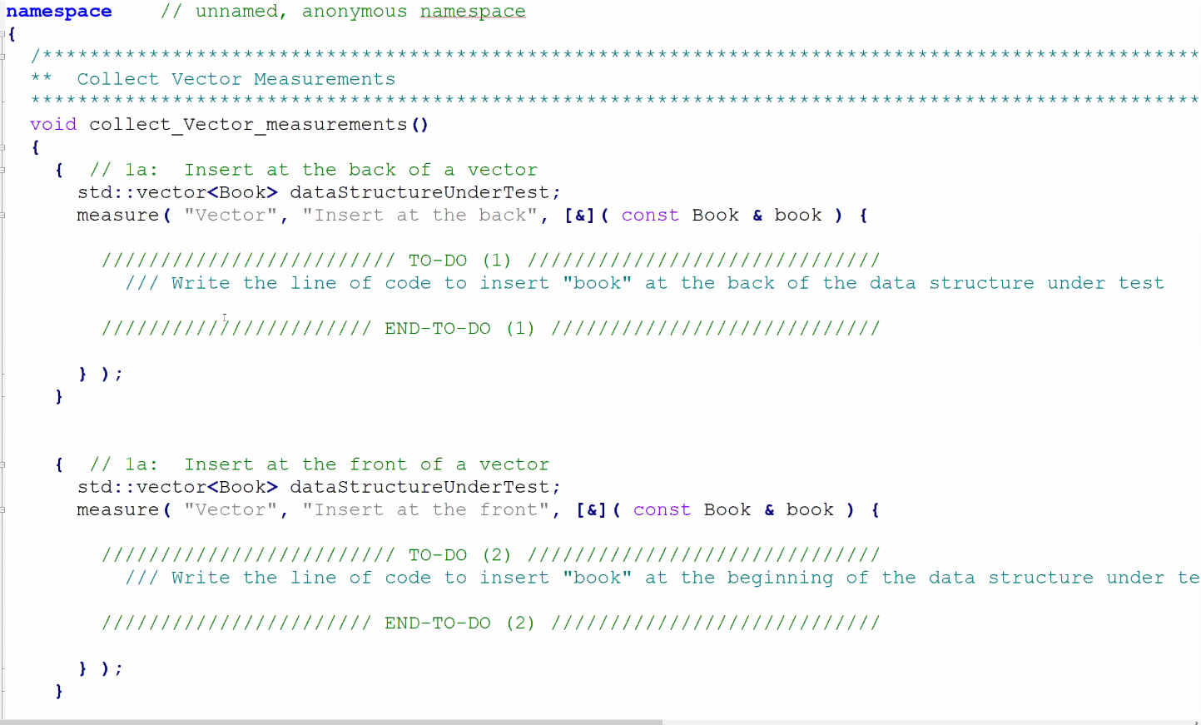
   1. We’re pushing a book to the back of a data structure under TEST and it is, in particular, a vector
   2. In TODO1  
      datastructureUnderTest.push_back(book);
   3. In TODO2  
      datastructureUnderTest.push_front(book);
   4. TODO5  
      //iterate through from .begin() to .end()  
      //return pointer you found in the vector
   5. TODO6  
      //insert at the begin of a doubly linked list
   6. TODO7  
      //insert at the back of a singly linked list
   7. Essay = 5 paragraphs, 2 pages,
      1. Submit pdf
      2. Talk about inserting into a tree vs hash table (draw a graph)
      3. Remove from a vector at back vs front (draw the graph)
      4. Searching a vector, DLL, SL, BST, Hash table (draw graph)
      5. Pick the final two
   8. Due in 9 days!
   9. The Final Project is your exam. DON’T SHOW UP!